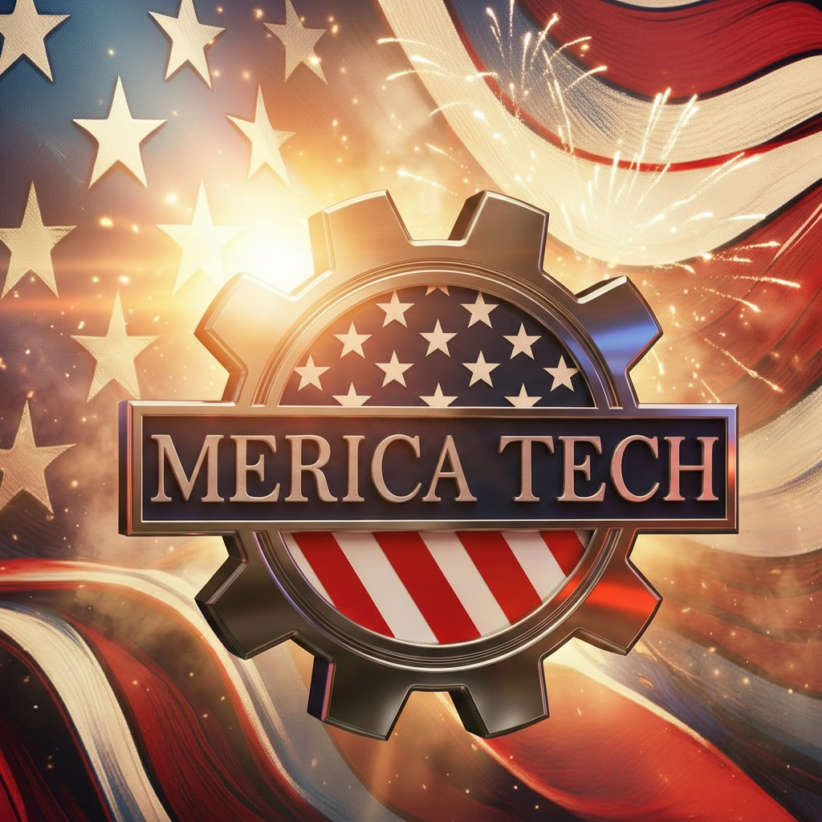 | COMBINED CAPABILITIES  Engineering Services | Technology Solutions | Defense & Commercial  Over 3 Decades Combined Experience | All IT & Engineering Domains

AI & Automation Systems
Capabilities  • ML pipelines & vector stores  • LLM API integration (OpenAI, Anthropic)  • Automated document processing & classification  • Docker containerized deployments  • CI/CD pipelines, GitHub Actions | Live Production Systems  • Market intelligence platform (14 services)  • RFP discovery & qualification engine  • IoT telemetry with secure data pipelines  • AI-assisted creative production tools

Industrial Automation & Controls
Capabilities  • Robotics & automation integration  • Cognex vision systems (sub-mm accuracy)  • PLC programming (Wago, Allen-Bradley)  • High-precision inspection systems  • Production line design & automation | Track Record  • Defense ordnance production (since 2012)  • CMMC compliance implementation  • Created & implemented CUI standards  • UL 2050 custodian (classified materials)

Prototyping & R&D
Capabilities  • Designing 3D printers & additive manufacturing  • Creation of complex 3D models using advanced custom AI workflows  • CNC machining & 3D printing  • CAD design (Fusion 360)  • Custom electronics enclosures  • Rapid prototype-to-production pipeline | IP & Innovation  • Patent filed: PVC Cabinet Design (2025)  • Patent pending: IoT Monitoring System  • Patent pending: First Responder Alerting System  • Opto-isolated signal capture hardware  • Custom IoT devices for first responder & municipal clients  • Cloud-based PA, lighting & alerting system integration

Network Infrastructure & Cybersecurity
Capabilities  • Cisco, Fortinet, Palo Alto, MikroTik ecosystems  • Firewall architecture & migration  • VPN, Zero Trust, network segmentation  • SD-WAN design & deployment  • Wireless infrastructure (Meraki, Aruba, Ubiquiti)  • BGP/OSPF routing protocols  • Cloud networking (AWS VPC, Azure vNet)  • Network monitoring & traffic analysis  • Load balancing & high availability  • DNS/DHCP architecture | Proven Scale  • Multi-site enterprise deployments (1,700+ locations)  • National retail network infrastructure  • Defense manufacturing network hardening  • PCI-compliant payment networks  • OT/IT convergence environments  • Multi-site FortiGate migrations

Compliance & Security Frameworks
Frameworks & Standards  • CMMC (Cybersecurity Maturity Model)  • NIST Cybersecurity Framework  • HIPAA technical controls & workflows  • PCI-DSS compliance  • FISMA & SOX controls  • CUI handling & classification  • UL 2050 & IEEE standards | Security Operations  • IAM & IEM implementation  • Red teaming & penetration testing  • SOC 2 readiness  • Prototyping for municipalities & first responders

Commercial AV & Structured Cabling
Capabilities  • HDMI matrix systems (8x8+)  • DSP audio processing (Atlas, QSC)  • Digital signage & display networks  • Structured cabling & fiber | Project Range  • National manufactured housing (multi-site)  • Training facilities & break rooms  • Commercial & enterprise installations

Solar & Renewable Energy
Capabilities  • Residential & commercial solar design  • Grid-tie & off-grid system architecture  • Battery storage & backup integration  • Inverter selection & configuration  • Load analysis & system sizing | Services  • Site assessment & shading analysis  • Permit documentation & utility coordination  • Installation & commissioning  • Monitoring system setup  • Maintenance & troubleshooting

Gaming & Entertainment Systems
Capabilities  • Unity-based gaming applications  • Touchscreen kiosk deployments  • IoT asset monitoring (patent pending) | Deployments  • 20+ commercial gaming kiosks (live)  • Custom game titles & branding
Christopher Johnson, CTO | Merica Tech LLC
Texarkana, TX 75501 | 870-648-8366 | merica-tech.com
Tailored Solutions. Trusted Engineering. Dependable Results.

